

UNIVERSITY OF TECHNOLOGY & EDUCATION

PROJECT ARTIFICIAL INTELLIGENCE

**PETS IDENTIFICATION &**

**THEIRS CHARACTERISTICS REAL-TIME**

In the 4.0 era, people apply artificial intelligence IMAGE DATA TYPE WAY TO COLLECT DATA

**INTRODUCTION**

**DATA PREPARATION**

 in all areas of life to save time and effort.

80% TRAIN

In the field of education, teachers' lectures need to be repeated many times to help students remember long and not forget - especially children from 3-6 years old.

20% VALIDATION

With the hope of being able to create an application that automatically identifies animals to become a useful teaching tool for teachers teaching students from 3 to 6 years old. With this animal identification application, in addition to being a teaching tool to create new learning inspirations for young children, besides watching animal videos or traditional pictures, it also helps parents tutor their children at home. It also helps children to review their own lessons at home and that leads to less burden on teachers

Total number of photos (28,867):

Train (18474) Validation (4619) Test (5774)

**RESULT & TESTING**

20% TESTING

Identifying the worldview for ages 3-6 is extremely important, so creating this model is extremely necessary.

**RESEARCH SUBJECTS**

The model that I made, the goal is to build a machine   
 learning model by CNN method capable of identifying   
 different animals through the computer's Webcam.

Because there are hundreds of animals in nature. So, I

PROCESS MAP OF PET IDENTIFICATION MODEL

would like to ask for permission to choose 15 typical

 animals to include in the model. The list of animals that

I choose to classify in the image data set includes: Dog,

Cat, Spider, Chicken, Sheep, Squirrel, Eagle, Gold Fish,

Turtle, Cow, Horse , Hamster, Hedgehog, Butterfly ...

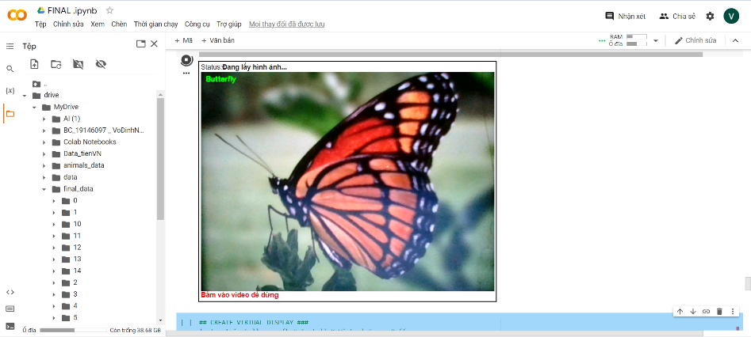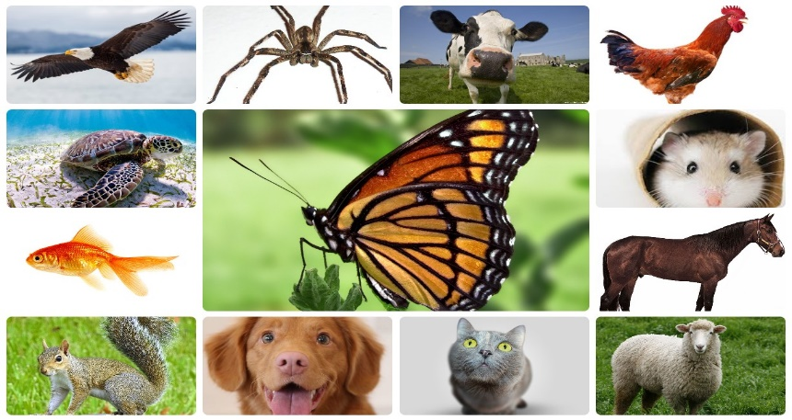

**CONTACT**

EMAIL : 19146097@student.hcmute.edu.vn

TELEPHONE : 0909265986

INSTRUCTOR: Nguyen Truong Thinh

STUDENT : Vo Dinh Nghi - 19146097

TOPIC : Identify 15 pets and their Characteristics Real-time